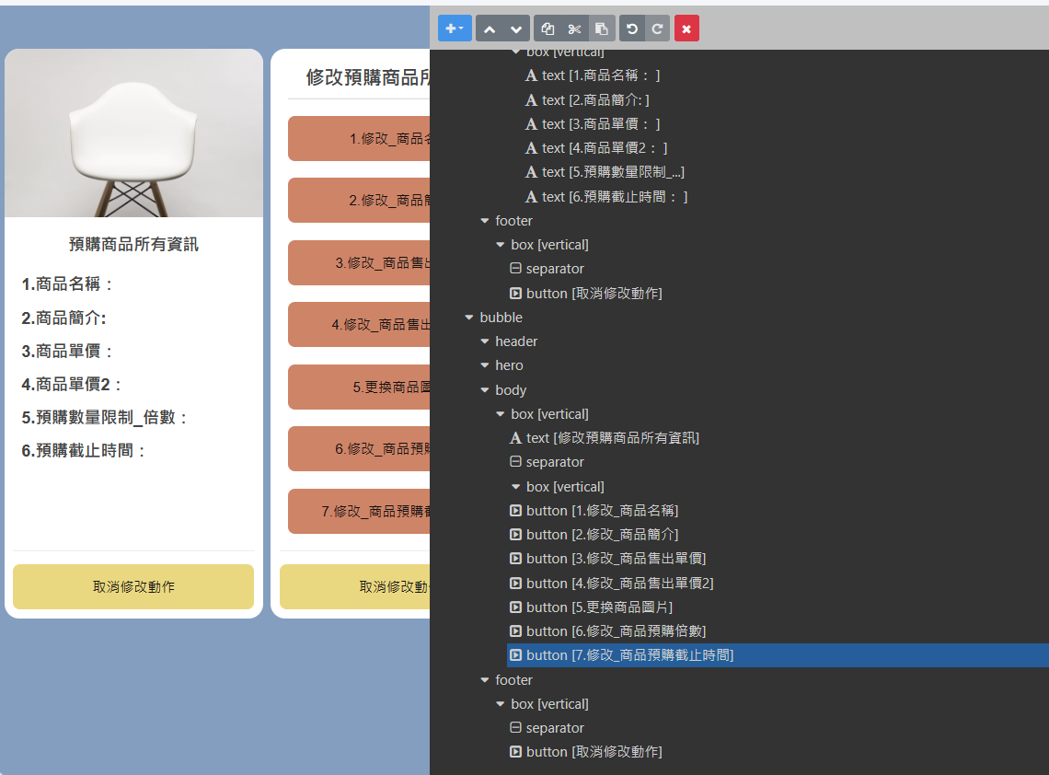

{

"type": "carousel",

"contents": [

{

"type": "bubble",

"hero": {

"type": "image",

"size": "full",

"aspectRatio": "20:13",

"aspectMode": "cover",

"url": "https://scdn.line-apps.com/n/channel_devcenter/img/fx/01_5_carousel.png"

},

"body": {

"type": "box",

"layout": "vertical",

"spacing": "sm",

"contents": [

{

"type": "text",

"text": "預購商品所有資訊",

"wrap": true,

"weight": "bold",

"size": "lg",

"align": "center"

},

{

"type": "box",

"layout": "vertical",

"contents": [

{

"type": "text",

"text": "1.商品名稱： ",

"size": "lg",

"margin": "none",

"wrap": true,

"lineSpacing": "16px",

"weight": "bold"

},

{

"type": "text",

"text": "2.商品簡介: ",

"weight": "bold",

"wrap": true,

"margin": "lg",

"size": "lg"

},

{

"type": "text",

"text": "3.商品單價： ",

"weight": "bold",

"size": "lg",

"margin": "lg",

"wrap": true,

"lineSpacing": "16px"

},

{

"type": "text",

"text": "4.商品單價2： ",

"weight": "bold",

"size": "lg",

"margin": "lg",

"wrap": true,

"lineSpacing": "16px"

},

{

"type": "text",

"text": "5.預購數量限制_倍數： ",

"margin": "lg",

"size": "lg",

"weight": "bold",

"lineSpacing": "16px"

},

{

"type": "text",

"text": "6.預購截止時間： ",

"size": "lg",

"margin": "lg",

"weight": "bold",

"lineSpacing": "16px"

}

],

"margin": "xxl",

"spacing": "none",

"position": "relative"

}

],

"margin": "xs"

},

"footer": {

"type": "box",

"layout": "vertical",

"spacing": "sm",

"contents": [

{

"type": "separator"

},

{

"type": "button",

"style": "secondary",

"action": {

"type": "message",

"label": "取消修改動作",

"text": "取消"

},

"color": "#EAD880",

"margin": "xl"

}

]

}

},

{

"type": "bubble",

"body": {

"type": "box",

"layout": "vertical",

"spacing": "xxl",

"contents": [

{

"type": "text",

"text": "修改預購商品所有資訊",

"align": "center",

"weight": "bold",

"margin": "none",

"size": "xl"

},

{

"type": "separator",

"margin": "md",

"color": "#A9A9A9"

},

{

"type": "box",

"layout": "vertical",

"contents": [],

"spacing": "none",

"margin": "none"

},

{

"type": "button",

"action": {

"type": "message",

"label": "1.修改_商品名稱",

"text": "【修改商品資訊】商品名稱"

},

"color": "#CE8467",

"style": "secondary",

"margin": "xxl"

},

{

"type": "button",

"action": {

"type": "message",

"label": "2.修改_商品簡介",

"text": "【修改商品資訊】商品簡介"

},

"color": "#CE8467",

"style": "secondary"

},

{

"type": "button",

"action": {

"type": "message",

"label": "3.修改_商品售出單價",

"text": "【修改商品資訊】商品售出單價"

},

"color": "#CE8467",

"style": "secondary"

},

{

"type": "button",

"action": {

"type": "message",

"label": "4.修改_商品售出單價2",

"text": "【修改商品資訊】商品售出單價2"

},

"color": "#CE8467",

"style": "secondary"

},

{

"type": "button",

"action": {

"type": "message",

"label": "5.更換商品圖片",

"text": "【修改商品資訊】更換商品圖片"

},

"color": "#CE8467",

"style": "secondary"

},

{

"type": "button",

"action": {

"type": "message",

"label": "6.修改_商品預購倍數",

"text": "【修改商品資訊】預購倍數"

},

"style": "secondary",

"color": "#CE8467"

},

{

"type": "button",

"action": {

"type": "message",

"label": "7.修改_商品預購截止時間",

"text": "【修改商品資訊】預購截止時間"

},

"style": "secondary",

"color": "#CE8467"

}

]

},

"footer": {

"type": "box",

"layout": "vertical",

"spacing": "sm",

"contents": [

{

"type": "separator",

"margin": "none"

},

{

"type": "button",

"flex": 2,

"style": "secondary",

"color": "#EAD880",

"action": {

"type": "message",

"text": "取消",

"label": "取消修改動作"

},

"margin": "xl"

}

]

}

}

]

}